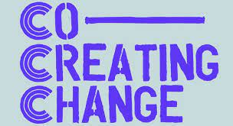

Co-Creating Change Alliance Co-ordinator
Application pack

​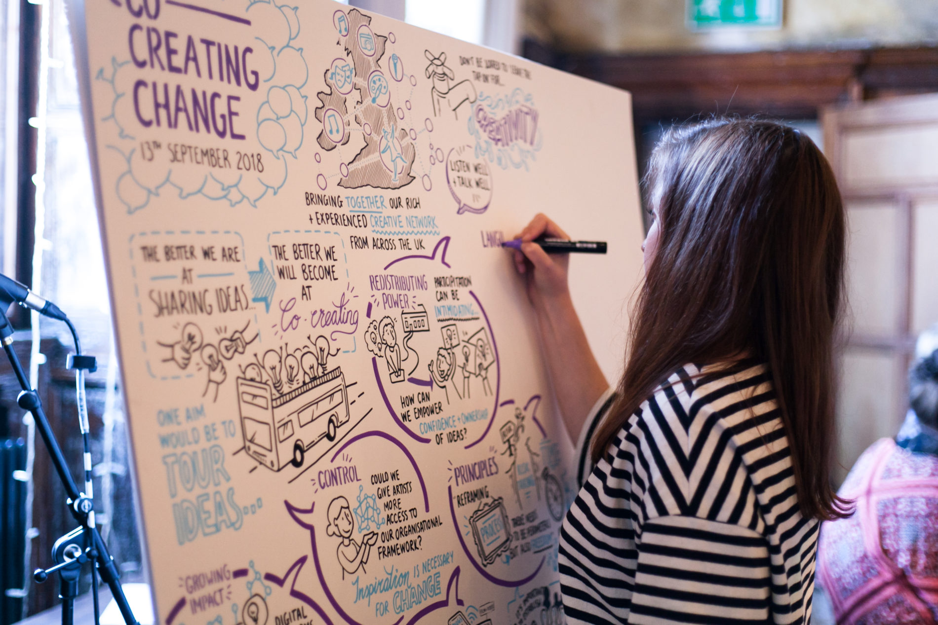

Thank You for Your Interest in the New Co-Creating Change Alliance.

We are looking for a dynamic co-ordinator / producer with a passion for arts-led co-creation, social justice and change-making. Ideally with experience in co-ordinating / growing national networks and producing events. This person will work with a national steering group and commissioning partners to relaunch and reinvigorate the Co-Creating Change Network - in its new Alliance form. Helping to steer and enhance the potential that began through the Co-Creating Change network (CCCN).

In this pack you will find more information about the Alliance, the role and how to apply.

What was the Co-Creating Change Network?

The Co-Creating Change Network was a national network of organisations, artists and grassroots organisations with social change at the heart of their work. The network ran programmes, supported commissions and advocated for a better understanding and appreciation of co-created practice, both in the arts sector and beyond from 2018-2022. The Co-Creating Change Network (CCN) was funded by the Paul Hamlyn Foundation, the Calouste Gulbenkian Foundation, and Arts Council England to the sum of £790,000 over four years. The network was co-ordinated by Battersea Arts Centre and supported by a core working group of organisations across 5 regions of the UK.
(See ‘Further information about the CCCN’ at the bottom of this doc for more context)
What Now?
The Co-creating Change Network showed the power and potential of supporting and investing in community-led arts based co-creation at a national level. And now, in a political landscape of increased polirisation the need for creative ways to bring communities together for social and environmental justice has never felt more important.

Thanks to funding from Esmee Fairbairn we can now re-launch and redevelop the network, as an Alliance, to extend its potential and impact. The Alliance will be funded for three years from April 2026 and will include national gatherings, peer exchange opportunities, regional co-creating change commissions and deep evaluation / sharing of learnings. We want to look afresh and explore together: What does co-creation really mean today, what change can it achieve and what makes arts-led co-creation distinct?
Existing regional partners of the Alliance currently include: KWMC, Heart of Glass, Powered by Can, Common Wealth Theatre and Strike A Light. With many other critical friends and previous network members.

The new Alliance will;

- Build on the networks previous successes,
- Distribute co-creation capacity/resource across England and Wales,
- Advocate on a national level for co-creation as a methodology.
- Diversify and expand the Alliance

(See ‘Further information about the Alliance’ at the bottom of this doc for more activity detail)

Who Are We Looking For?
We are looking for a dynamic co-ordinator with a passion for arts based co-creation, social justice and change making and experience in co-ordinating and delivering national networks, producing events and overseeing programmes. We need someone who is independent and proactive as well as an excellent collaborator.

Job Description
You will work collaboratively with the CCA steering group and commissioning partners across 4 regions: North, South-West England, Midlands and Wales over a 3 year period to:
- Connect partners and ensure delivery across all activity strands;
- Organise and convene national gatherings with regional partners; (in regional locations)
- Support the steering group, convening meetings;
- Organise co-learning opportunities and exchange trips;
- Oversee comms (including working with recruited comms specialists to re-launch a new brand for the Alliance) and manage the CCA website;
- Support the development of learning toolkits and resources;
- Support fundraising for additional match funding to expand ambitions;
- Facilitate advocacy work and ensure dissemination of learnings.

We anticipate the successful person will be a dynamic and motivated individual with a range of the following expertise and qualities:

Person Specification
- Knowledge of and passion for co-creation practices (beyond arts sector experience welcome)
- Experience of developing / co-ordinating national networks, or national projects
- Ability to work independently and proactively
- An understanding of arts, cultural, community and social justice sectors
- Experience of fundraising
- Event production skills, from small to large scale (including risk assessments)
- Experience managing project budgets
- Artist liaison and support
- Excellent writing skills, with experience of writing funding bids, think pieces and copy
- Excellent listening, communication and collaborative skills
- Willingness to travel across the UK and confidence with remote working
- Knowledge and experience of navigating political cultural landscapes and current policies
- Strong equity, inclusion and anti-racist practices

Desirable:
- Facilitation skills

Job Details
Job Title: Co-Creating Change Alliance Co-ordinator (CCA Co-ordinator)
Fee: £11,700 per year (estimated 1 day per week) with additional access and travel budget
Hours: Working hours to be agreed with KWMC coordinating producer
Contract Period: 3 years
Responsible to: KWMC as employers and the CCA steering group as governance body
Location: This position could be done fully remotely, or hybrid, or you could be based at the office at KWMC in Bristol. Must be willing to travel across UK.
Application & Recruitment Process

Timeline
Application deadline: Monday 13th April 2026 (23:59pm)
Interviews: Friday 24th April (online)
Start-Date: As soon as possible. Ideally start of May.

Please fill in this form: tinyurl.com/co-creating-change, which will ask you to upload a CV and answer these questions:

- Why you are interested in the role (250 words)
- Tell us about your relevant experience, background and how you meet the skills and experience set out in the person specification (up to 1000 words)

You can submit your application in written form (via the link above) or in audio, or video format (sent via a transfer link that will not expire) – whichever you’re most comfortable with. All applications will be assessed according to the same criteria and submitting in a different format will not affect your chances of being selected.

Recruitment Process
We welcome and encourage applications from those currently underrepresented in our workforce and in the arts sector; particularly any applicant who identifies as working-class, as a person of colour, transgender, non-binary or genderqueer, D/deaf, Blind, visually impaired, Disabled or Neurodivergent.

As part of our commitment to being a Disability Confident Employer we guarantee an interview to anyone who identifies as disabled (as defined by the Equalities Act 2010) that meets the essential criteria set out in the person specification.

Contact
Please get in touch with any questions. You can contact Martha by emailing martha.king@kwmc.org.uk or calling 0117 903 0444.

Further Information about the Co-Creating Change Network 2018-2022

The overarching objectives of the project were to:

- Develop a more collegiate and skilled sector by supporting the network to come together and share skills and knowledge
- Develop co-created practice by commissioning the development of new or existing co-created methodologies
- Better share, grow and spread methodologies by supporting a number of commissions to 'tour' nationally and/or internationally with multiple partners
- Develop the market for co-created practice by hosting an international marketplace event
- To work with funders, critics and policy makers to develop the conditions within which this work will flourish

The programme activity included:

- National network gatherings – twice yearly for all members
- Professional development sessions led by members for members
- Online space to share conversations and resources
- Commissions – ‘Project Commissions’ to develop and ‘Growth Commissions’ to grow methodologies for co-creation
- Culminating in an international marketplace of co-created practice
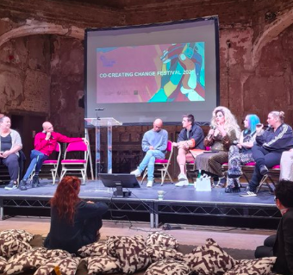
- A series of ‘learning conversations’ with ‘elders’ of the co-creation sector, funders, cross-sector partners and critics

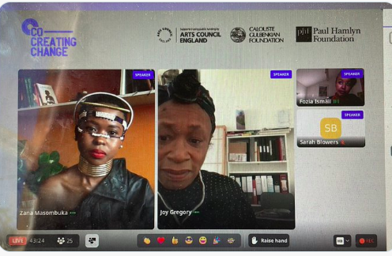

Between 2018-2022 the project successfully:
- Built a network of over 293 members
- Was awarded 11 project commissions totalling £140,000 and five growth and replica commissions totalling £150,000.
- Delivered three in person national network gatherings
- Delivered two online national network gatherings
- Initiated and delivered five regional network meetings developing regional hubs and networks led by core network members
- Delivered five online learning sessions and conversations sharing resources and bringing network members together
- Produced a week long national/international live and digital festival marketplace event.
- Commissioned 10 blogs about co-creation
- Worked with an independent evaluator and published 8 reflective blogs and sixteen case studies
- Met regularly with key funders to share our learning and explore future partnerships.
- Co-authored a large case study commissioned by Arts Council England in partnership with Heart of Glass showcasing good examples of co-creation nationally.

You can watch in-person & virtual sessions from the Nov 2021 Co creating Change festival here. And read lots of case studies, reports and stories here.

Further Information about the Co-Creating Change Alliance 2026-2029

Funded Alliance activity (NB: details may change)

Regional lead partners distributing and supporting up to 4 local place-based commissions. Commissions up to £20K plus production, access and presentation budgets.

PLACE BASED COMMISSIONS

Facilitation of at least 2 national gatherings.
Resource creation, advocacy and dissemination to help people get started with /adopt co-creation.

BUILDING CONNECTIONS AND ADVOCACY

Quarterly exchange trips (in person and remote exchange trips)

EXCHANGE TRIPS AND
CO-LEARNING

Place-based Commissions

There will be 3-4 place-based commissions distributed by the regional partners (KWMC, Common Wealth Theatre, Powered by Can and Heart of Glass), staggered over the 3 years. The commissions will be open call and could be any artform. There will be a focus on commissions that model co-creation as a tool for imagining and making new futures – and focus on the quality of the process, and not only about making co-created artwork. Each commission will respond to local priorities and support recipients to take action, better advocate for their work, scale it up, or replicate it.
To help steer the commissions, local advisory groups will be established.

Building Connections

The Alliance will host at least 2 annual national gatherings bringing together artists, creative practitioners, arts organisations, community members and organisations to connect with other co-creators and share practice, learning and resources. To enable freelancers and community members to engage equitably in the gatherings, we have included a budget for bursaries to cover time, travel and accommodation costs. The national gatherings will be hosted in the regions (e.g: Bradford, Bristol or West Bromwich/Birmingham) by the lead partners, bringing together the different communities involved. The ambition is that as well as providing a space for people to connect and share learning, they will provide the launch pad for regional networks with regular meet ups hosted by the lead partners. The national gatherings will showcase best practice from the Alliance and network members, commissioned artists and other best examples from the UK and abroad working in social change.

Advocacy

The Alliance will facilitate advocacy work, supported by a communications specialist, to ensure dissemination of learning, toolkits and case studies in and outside the arts. During the first phase, CCCN developed a website with extensive resources and case-studies on the impact of the network (please visit http://www.cocreatingchange.org.uk). The case studies for the commissioned projects will act as toolkits for other organisations thinking about developing their co-created work. Resources will be a mixture of forms including written, video and illustrated storytelling. Throughout the programme we will also produce a series of think pieces/blogs by Alliance members and the commissioned projects sharing latest thinking and practice.

Exchange trips/ Co-Learning

The lead partners are all specialists and sector leaders in community-led practice and co-creation. But each has very distinctive practice. Exchange trips and co-learning will provide a vital space to understand and learn from each other’s practice. The partners can then bring this back into the communities they are based in. The partners will meet 4 times per year, twice in person and twice remotely. The co-learning and exchange trips will provide a safe environment to share experiences, exploring honestly what has and hasn’t worked. There will also be places for early-career practitioners to join the exchange trips as part of the Alliances commitment to supporting professional development.

Evaluation:

We will work with an evaluator to devise an iterative evaluation framework. Plans and ideas will be practically tested and evaluated throughout our work, with feedback from communities and stakeholders. This will help us learn from challenges and mistakes, respond more quickly and adapt when things go wrong. We want to explore how to measure and articulate the impact of co-created practices. We want to explore the different languages needed to articulate the social impact this work has on communities and local economies for different sectors. We plan to gather a body of case-studies (that will emerge from the commissions) that in turn will help advocate for this work to stakeholders and decision makers outside the arts.

Who will be the accountable body of the new Co-Creating Change Alliance?

KWMC will be the accountable body under which the Alliance operates. KWMC will hold and manage the funds and finances, agreements and contracts on behalf of the CCCA, including employing and supporting the freelance roles. A steering group composed of regional partners, plus critical friends will meet quarterly to monitor and evaluate progress.

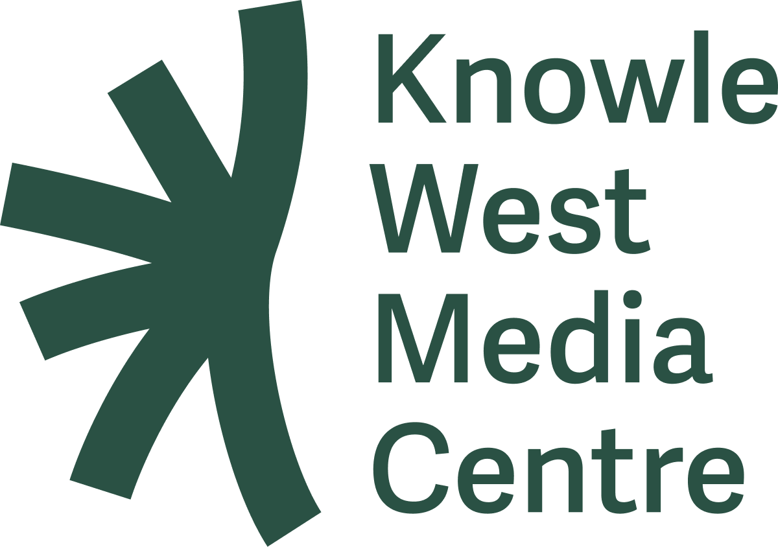

Credits

The Co Creating Change Network first iteration, 2018-2022 was funded by:

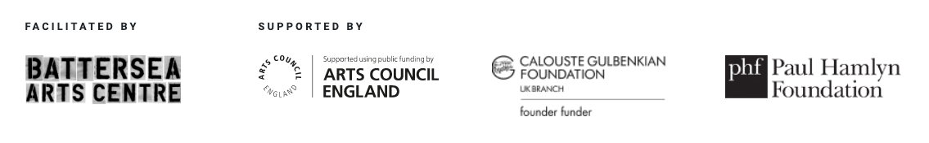

The new Co-Creating Change Alliance is funded by Esmee Fairbairn .
